Day 23 – 02/08/2025

// Task001: Tags annotation.  
  
package org.example;  
  
import org.junit.jupiter.api.Tag;  
import org.junit.jupiter.api.Test;  
import static org.junit.jupiter.api.Assertions.*assertEquals*;  
  
public class JUnitPriorTest {  
 @Test  
 @Tag("firstPriority")  
 void product(){  
  
 }  
  
 @Test  
 @Tag("firstPriority")  
 void quot(){  
 int a =2, b=3, quot;  
 quot = b/a;  
 *assertEquals*(1, quot);  
 }  
  
 @Test  
 @Tag("fastTag")  
 void diff(){  
 int a=2, b=3, doff;  
 doff = b-a;  
 *assertEquals*(1, doff);  
 }  
  
 @Test  
 @Tag("slowTag")  
 void add(){  
 int a =2, b=3, sum;  
 sum = a+b;  
 *assertEquals*(5, sum);  
 }  
  
}

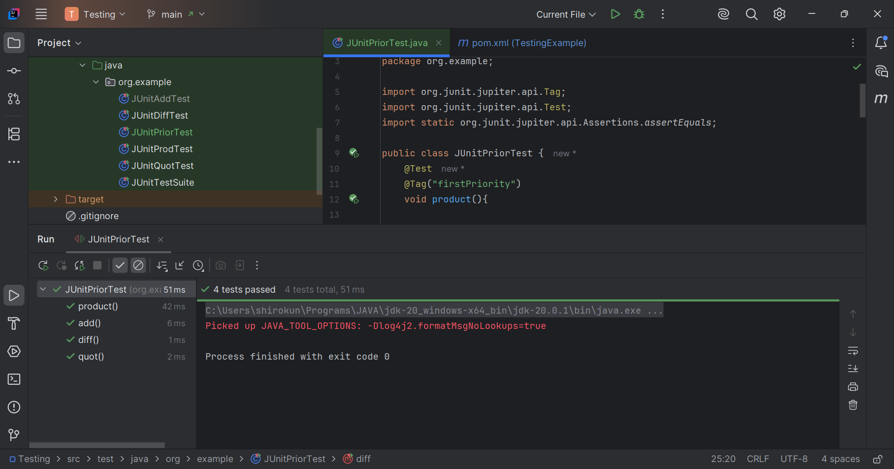

// Task002: Factory model design pattern.  
  
package Day23;  
  
public class Pizzeria {  
 public static void main(String[] args) {  
 PizzaFactory factory = new PepperoniPizzaFactory();  
 Pizza pizza = factory.createPizza();  
 if(pizza != null){  
 System.*out*.println("Enjoy your pizza.!!");  
 }  
 }  
}

